Royal Manticoran Army Deployment Request Form

NAME: (Last, First, MI)
RANK and RMN#:
INSTALLATION UNIT REQUEST: Bivouac – Barracks – Outpost - Fort
UNIT LOCATION (State and Country as applicable)
IS THIS A NEW REQUEST OR UPDATE? New______ Update_______
REQUESTED NAME (if new unit request or designation change)
IF UNIT UPDATE, WHAT IS CURRENT DESIGNATION? Attach current personnel roster.
THEATER COMMAND – BATTLEGROUP – REGIMENTAL COMBAT TEAM (filled out by ODCSOPS)
APPROVED______ NOT APPROVED_______ If not approved, provide attached documentation.
DATE:

Deployment Requests:
- All deployments require a deployment request form to be filled out and submitted to the ODCSOPS.
- Requests for new Installations (Bivouac) require a name designation recommendation.
- Requests for updated Installations require minimum manpower and the current member roster attached.
- Requests that are not approved must have the documented reasons attached for return to the requester.

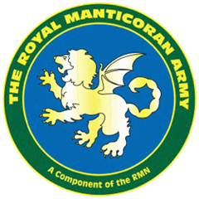

RMA-Form-001OPS

